Learning Management System Registrar Job Aid for Help Desk Personnel
Contents
Purpose 2
Job Aid Organization 2
Your Tasks 3
Accessing the Administrative Menu 4
Accessing User Profiles 5
Add a new user profile 6
Edit an existing user profile 10
Assign training role(s) to a user 15
Remove a user’s training role 21
Email login id and password to a user 24
Delete a user profile 26
Look up Registrars 29

Purpose

The Home and Community Services Information System (HCSIS) project is using a Learning Management System (LMS) to assist in training logistics, including registration and tracking attendance. User profiles include all contact and location information, the user’s login id and password and the user’s training roles.

Job Aid Organization
This job aid is organized with the following subsection:
- Your Tasks: The Tasks section outlines the steps necessary to complete this job aid. In addition, this section identifies the HCSIS screens used to complete the tasks.

Your Tasks

As a registrar, you can perform the following tasks:
Task | Page Number
Access the Admin Menu | 6
Access the user profiles | 7
Add a new OMR user profile | 8
Edit an existing user profile | 12
Assign training role(s) to an OMR user | 17
Remove an OMR user’s training role | 23
Email login id and password to a user | 26
Delete an OMR user profile | 28
Look up Registrars | 31

Detailed instructions are included in this job aid packet. The documentation for each task is divided into the following sections:
Section | Use
Procedure Description | This is a brief summary of the purpose of the screen. It includes the context of this screen within the process.
Dependencies | The steps that precede the start of a procedure.
Steps | This describes the steps for completing the procedure.

Accessing the Administrative Menu

Procedure Description:

Use this screen to access the Admin Menu.

Dependencies:
- You will not have access to the Admin Menu until the System Administrator has assigned you the security role of Registrar.
- You must log onto the LMS in the following location: www.humanservices-r.state.pa.us/hcsislms

Steps:
- Choose the “Admin Menu” link.

NOTE: Click on the link on the left menu or the top menu bar to access the Administrative Menu. If the Admin Menu is not displaying on the left menu bar, click on the plus (+) sign next to LMS Admin.

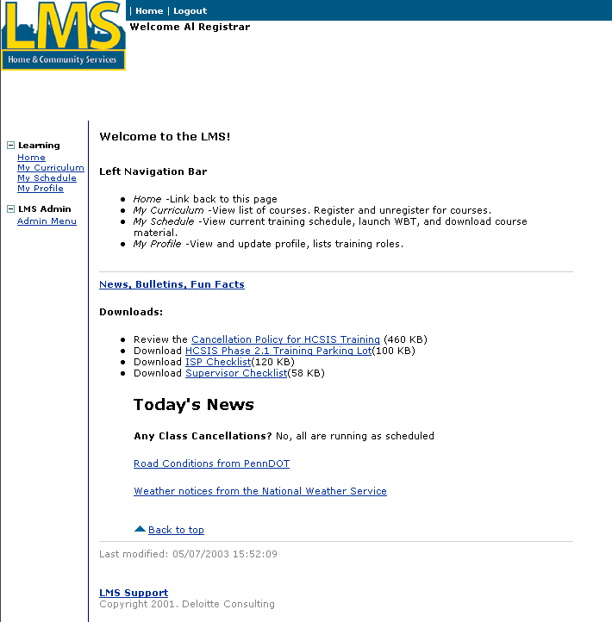

Accessing User Profiles

Procedure Description:

After you select Admin Menu, the LMS displays the Admin Menu with a link to Users.

Dependencies:
- Access this screen by clicking the “Admin Menu” link
- You must select one of the Admin Menu links.

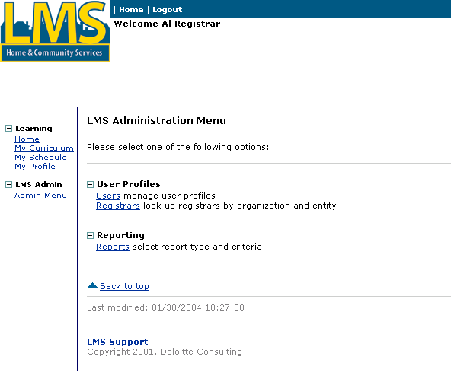

Steps:
- Choose the “Users” link.

Add a new user profile

Procedure Description

After you select the “Users” link, the User Profiles page displays with a link to add a new user.
Dependencies
- You must click “Users” from the Admin Menu to access this page.

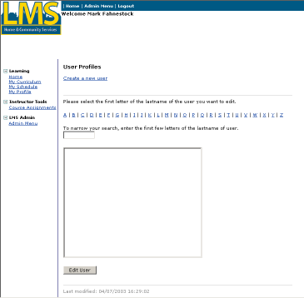

Steps
- Choose the “Create a new user” link

Add a new user profile (Continued)

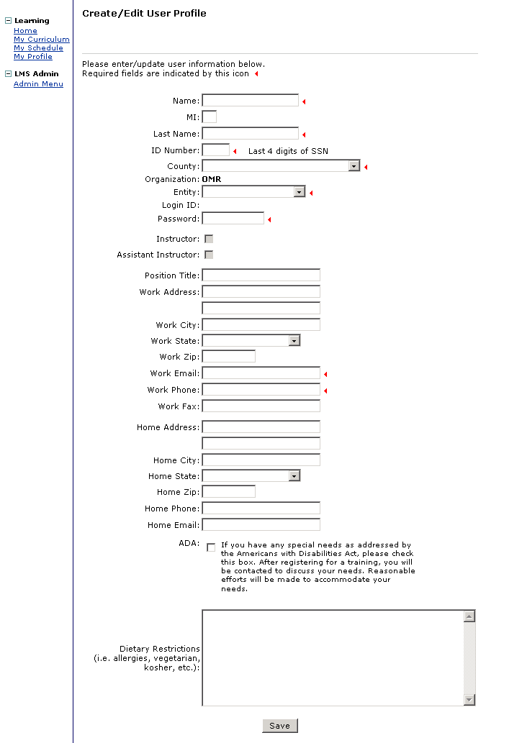

Add a new user profile (Continued)
- On the “Create/Edit” User Profile” screen, complete the following fields:

Note: Mandatory fields must have values. Optional fields may be blank.

Note: The user’s organization is OMR. Contact the user’s registrar or the LMS System Administrator to add a user for other organizations.
Field Name | Description
Name | Mandatory. Enter user’s first name.
MI | Optional. Enter user’s middle initial.
Last name | Mandatory. Enter user’s last name.
ID Number | Mandatory. Enter the last 4 digits of user’s social security number.
County | Mandatory: Select the user’s county.
Entity | Mandatory. Select the user’s entity. The list consists of OMR entities only.
Password | Mandatory. Enter a password.
Position Title | Optional. Enter user’s job title.
Work Address | Optional. Enter user’s primary work street address.
Work City | Optional. Enter user’s primary work city address.
Work State | Optional. Enter PA.
Work Zip | Optional. Enter the zip code for user’s primary work address.
Work Email | Mandatory. Enter user’s email address.
Work Phone | Mandatory. Enter user’s work phone number.
Work Fax | Optional. Enter user’s fax number.
Home Address | Optional. Enter user’s primary home street address.
Home City | Optional. Enter user’s primary home city address.
Home State | Optional. Enter PA.
Home Zip | Optional. Enter the zip code for user’s primary home address.
Home Phone | Optional. Enter user’s home phone number.
Home Email | Optional. Enter user’s email address.
ADA | Optional: Check this box if the user has any special needs as addressed by the Americans with Disabilities Act.
Dietary Restrictions | Optional: Enter any special dietary requests. This box can also be used to enter any notes pertaining to the user.
- Click “Save”.
- To prevent entry of duplicate user profiles the system performs several tests. If the entries do not pass the tests, contact the LMS System Administrator. The tests are:
- The login id cannot already exist in the LMS
- The combination of last name and email cannot already exist in the LMS.
- The combination of first name and last name cannot already exist in the LMS
- If the new profile passes all tests, the system will generate a login id using the user’s initials and SSN.

NOTE: The LMS will send an email message within 24 hours to the email account you specified with the user id and password.

Edit an existing user profile

Procedure Description

After you select the “Users” link, the User Profiles page displays.
Dependency
- You must click “Users” from the Admin Menu to access this page.

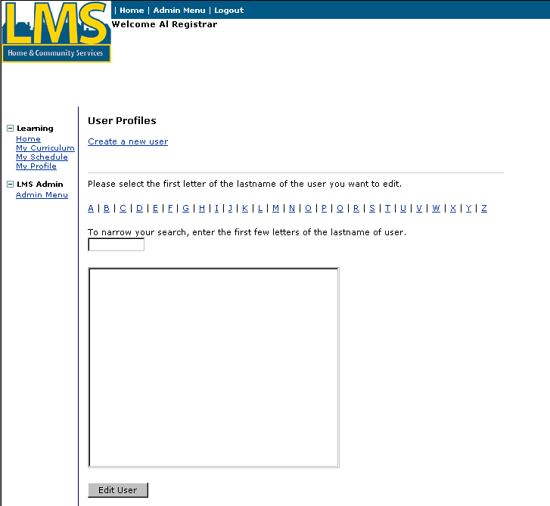
Steps
- Select the first letter of the last name of the user whose profile you wish to edit. The LMS populates the list box with users whose last name starts with the letter you selected.
- Enter the first few letters of the last name of the user whose profile you wish to edit in the box provided. As the letters are entered, the list box displays only the users that match your search. Note: Alternatively, you can scroll through the list box until you find the name of the user that you want to edit. If you are using a browser other than Internet Explorer, you will not see the box to enter the first few letters of the name.
Edit an existing user profile (continued)
- Click on the user in the list box and then click on the [Edit User] button.

Note: Alternatively, if you are using Internet Explorer, you can double click on the user name to display the profile.
Edit an existing user profile (continued)

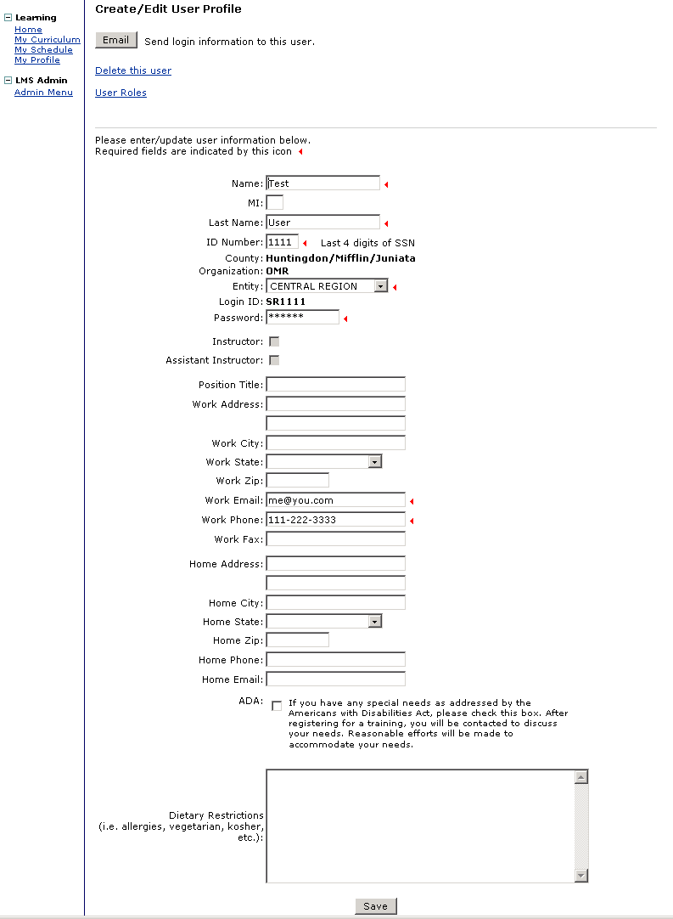

Edit an existing user profile (continued)
- On the “Create/Edit User Profile screen, complete the following fields:

Note: Mandatory fields must have values. Optional fields may be blank.

Note: The user’s organization is OMR. Contact the LMS System Administrator to change the user’s organization.
Field Name | Description
Name | Mandatory. Enter user’s first name.
MI | Optional. Enter user’s middle initial.
Last name | Mandatory. Enter user’s last name.
ID Number | Mandatory. Enter the last 4 digits of user’s social security number.
Entity | Mandatory. Select the user’s entity. The list consists of OMR entities only. Note: If you are editing someone other than an OMR user, you will not be able to change the entity.
Password | Mandatory. Enter a password.
Position Title | Optional. Enter user’s job title.
Work Address | Optional. Enter user’s primary work street address.
Work City | Optional. Enter user’s primary work city address.
Work State | Optional. Enter PA.
Work Zip | Optional. Enter the zip code for user’s primary work address.
Work Email | Mandatory. Enter user’s email address.
Work Phone | Mandatory. Enter user’s work phone number.
Work Fax | Optional. Enter user’s fax number.
Home Address | Optional. Enter user’s primary home street address.
Home City | Optional. Enter user’s primary home city address.
Home State | Optional. Enter PA.
Home Zip | Optional. Enter the zip code for user’s primary home address.
Home Phone | Optional. Enter user’s home phone number.
Home Email | Optional. Enter user’s email address.
ADA | Optional: Check this box if the user has any special needs as addressed by the Americans with Disabilities Act.
Dietary Restrictions | Optional: Enter any special dietary requests. This box can also be used to enter any notes pertaining to the user.

- Click “Save”.

Assign training role(s) to a user

Procedure Description

Select an existing user. Select a training role from a list and assign the role to the user.

Note: You will only be able to assign training roles to OMR users. The “Add a New Role” link will not display for users in other organizations.
Dependencies
- Select “Users” from the Admin Menu.
- Select the link for the first letter of the last name of the user whose profile you wish to edit. The list box will display the users with the last names you selected.
- Enter the first few letters of the last name in the box provided. As the letters are entered, the list box displays only the users that match your search.
- Alternatively, scroll through the list box for the user’s name. If you are NOT using Internet Explorer, the box to enter the first few letters of the last name will not display.
- Select a user and then click on “Edit User”. The LMS displays the selected user profile.
Assign training role(s) to a user (continued)

Steps
- To move to the user roles section of the user profile page, click on the “User Roles” link at the top of the page.
Assign training role(s) to a user (continued)

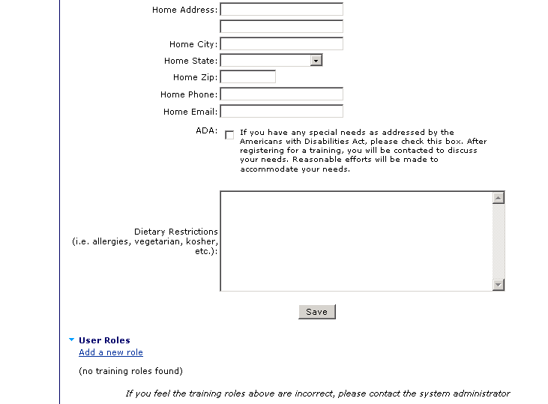
- Click on the “Add a new role” link.
Assign training role(s) to a user (continued)

The Assign Training Role(s) to a User page displays. Training roles that have not been assigned to the selected user are listed in the Training roles list box.
- Select a role from the Training roles list.
- Click the right arrow [→] button to move the roles to the Assign roles list box.
Assign training role(s) to a user (continued)

The role you selected displays in the Assign roles list box.
Tip: If you have moved a role to the Assign roles list box in error, select the role in the Assign roles box and click the left arrow [←] to remove it.
- Repeat Steps 3 and 4 to assign more training roles to the user.
- Click the “Assign Roles” button.
Assign training role(s) to a user (continued)

The user’s profile displays with the assigned training roles listed under “User Roles” at the bottom of the page.
- Click “Save” to save settings and return to the “Select User Profile” page.

Remove a user’s training role

Procedure Description

Select an existing user. Select a training role that has been assigned to a user and remove it.

Note: You will only be able to delete training roles from OMR users. The “Delete” links will not display for users in other organizations.
Dependencies
- Select “Users” from the Admin Menu.
- Select the link for the first letter of the last name of the user whose profile you wish to edit. The list box will display the users with the last names you selected.
- Enter the first few letters of the last name in the box provided. As the letters are entered, the list box displays only the users that match your search.
- Alternatively, scroll through the list box for the user’s name. If you are NOT using Internet Explorer, the box to enter the first few letters of the last name will not display.
- Select a user and then click on “Edit User”. The LMS displays the selected user profile.
Remove a user’s training role (continued)

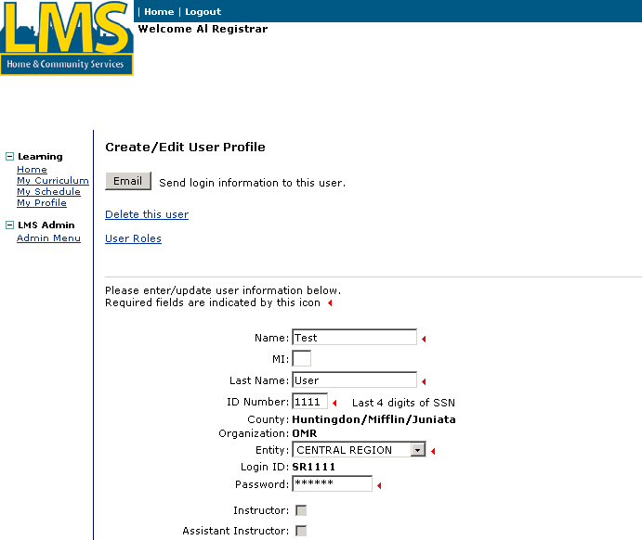

Steps
- To move to the user roles section of the user profile page, click on the “User Roles” link at the top of the page.
Remove a user’s training role (continued)
- Click on the “Remove” link for the training role that you wish to remove. A confirmation box will display

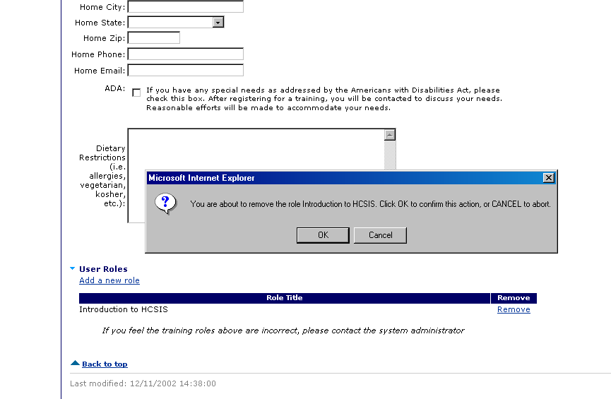
- Click on “OK” to confirm removal of the training role.
- The user’s profile will display with the selected training role removed from the list.
- Click “Save” to save settings and return to the “Select User Profile” page.

Email login id and password to a user

Procedure Description

Select an existing user. Send an email to the user with his or her login id and password.
Dependencies
- Select “Users” from the Admin Menu.
- Select the link for the first letter of the last name of the user whose profile you wish to edit. The list box will display the users with the last names you selected.
- Enter the first few letters of the last name in the box provided. As the letters are entered, the list box displays only the users that match your search.
- Alternatively, scroll through the list box for the user’s name. If you are NOT using Internet Explorer, the box to enter the first few letters of the last name will not display.
- Select a user and then click on “Edit User”. The LMS displays the selected user profile.
Email login id and password to a user (continued)

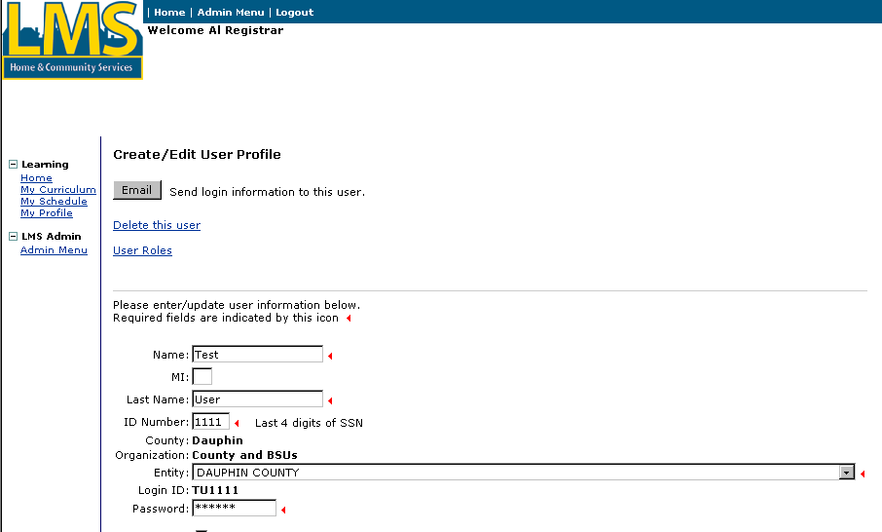

Steps
- Click on the “Email” button at the top of the profile.
- If the email was successfully sent, a confirmation message will display above the “Email” button.

Delete a user profile

Procedure Description

Select an existing user. Delete the user.

Note: You will only be able to delete OMR users. The “Delete this user” link will not display for users in other organizations.
Dependencies
- Select “Users” from the Admin Menu.
- Select the link for the first letter of the last name of the user whose profile you wish to edit. The list box will display the users with the last names you selected.
- Enter the first few letters of the last name in the box provided. As the letters are entered, the list box displays only the users that match your search.
- Alternatively, scroll through the list box for the user’s name. If you are NOT using Internet Explorer, the box to enter the first few letters of the last name will not display.
- Select a user and then click on “Edit User”. The LMS displays the selected user profile.

Delete a user profile (continued)

Steps
- Click on the “Delete this user” link at the top of the profile.
Delete a user profile (continued)
- A confirmation will display. Click on the “OK” button to delete the user. The system will mark the user as deleted and return to the “Select User Profile” page.

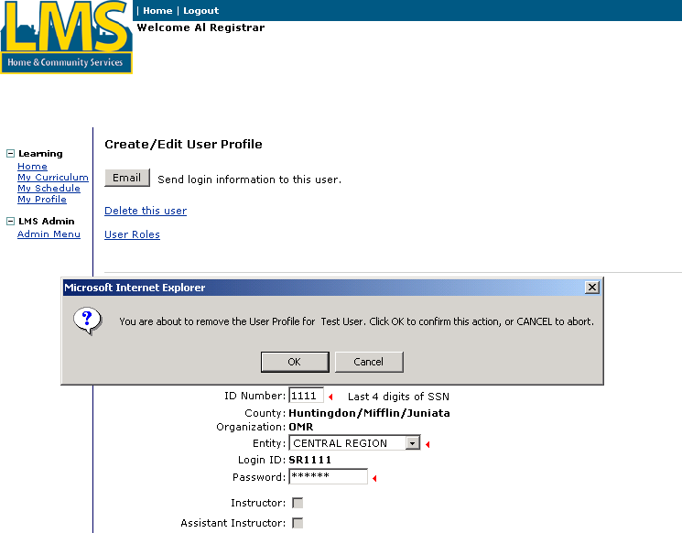

Look up Registrars

Procedure Description

Look up a Registrar for an entity.
Dependencies
- Select “Admin Menu”
- Select “Registrars” from the Admin Menu.
Look up Registrars (continued)

The “LMS Registrars” page displays:

Steps
- Select an Organization from the list.
- Select an Entity from the list.
Look up Registrars (continued)

The LMS displays contact information for the Registrar(s) associated with the entity you selected.

You have completed this job aid.

